**(ONLINE CLASS TEST MANAGEMENT SYSTEM-OCTMS)**

**Submitted by**

**1. Name: Md Amir Hamza Robel**

**(ID: ECSE160100409)**

**2. Name: Abdul Ahad**

**(ID: ECSE160200435)**

A Project Report Submitted in Partial Fulfillment of the Requirements for the Degree of Bachelor of Science in Computer Science & Engineering



DEPARTMENT OF COMPUTER SCIENCE AND ENGINEERING

NOTHERN UNIVERSITY BANGLADESH

August 2019

APPROVAL

The Project Report “**Online Class Test Management System**” submitted by Mr. Md Amir Hamza Robel (ID: ECSE160100409) and Mr. Abdul Ahad (ID: ECSE160200435) to the Department of Computer Science and Engineering, Northern University Bangladesh, has been accepted as satisfactory for the partial fulfillment of the requirements for the degree of Bachelor of Science in Computer Science and Engineering and approved as to its style and contents.

Board of Examiners

1. Md. Raihan Ul Masood (Supervisor)

1. (Examiner)
2. (Examiner)

---------------------------------------

Md. Raihan Ul Masood

Associate Professor and Head

Department of Computer Science and Engineering

Northern University Bangladesh

DECLARATION

We, hereby, declare that the work presented in this Project report is the outcome of the investigation performed by us under the supervision of Md. Raihan Ul Masood, Associate Professor and Head, Department of Computer Science and Engineering, Northern University Bangladesh. We also declare that no part of this Project has been or is being submitted elsewhere for the award of any degree or diploma.

Signature

……………………………

Name: Md Amir Hamza Robel

(ID: ECSE160100409)

..............................................

Name: Abdul Ahad

(ID:ECSE160200435)

**Candidates**

ACKNOWLEDGEMENTS

First of all we would like to thank the Almighty ALLAH. Today we are successful in completing our work with such ease because He gave us the ability, chance, and a cooperating supervisor.

We are indebted to a number of individuals in academic circles as well as in university faculties who have contributed to prepare the book. Their contributions are important in so many different ways that we find it difficult to acknowledge them in any other manner but alphabetically. In particular, we wish to extend our appreciation to our respected supervisor **Md Raihan Ul Masood**, Associate Professor & Head, Dept. of Computer Science & Engineering, Northern University Bangladesh, our honorable Coordinator, Faculty of Science **and Engineering,** and other respected faculties of Science Faculty Northern University Bangladesh, for their valuable suggestions on preparing and improving the presentation and the book.

We also want to convey our thanks to our fellow friends for their great encouragement and suggestions. We are thankful to my friend Md Asadullah Galib for his tutorials and supports.

Again we would like to give thanks to our honorable supervisor **Mr. Md Raihan Ul Masood** for his commitment to excellence in all aspect of the production of this book and completion of the work.

Last of all, we are grateful to our family members; who are, always with us in our every step of life.

***Dedicated to Our Parents***

ABSTRACT

Online Class Test Management System is a Web Application. Through OCTMS an institute can arrange their exam (Class Test, Quiz) by including both teachers and students virtually. The teacher can make CT with proper time scheduling which is next appeared on the student dashboard. Students can join the CT in particular time and can see their result instantly after completing the exam. The admin has the supreme authentication to edit/add subject, page contents, user rules & approval. It records all the logs for future queries.

TABLE OF CONTENTS

APPROVAL II

DECLARATION III

ACKNOWLEDGEMENTS IV

ABSTRACT VI

TABLE OF CONTENTS 0

Table of Figures 1

Chapter I 2

1 Introduction 2

1.1 Overview 2

1.2 Background Study 2

1.3 Objectives of this Project 4

1.4 Overview of the Project Report 4

Chapter II 5

2 Contributions and Outcomes 5

2.1 Our Contribution 5

2.2 Project Features 5

2.3 Example 6

Chapter III 7

3 Development Methodology 7

3.1 Tools 7

3.2 Conceptual Mind map 7

3.3 System Architecture 8

3.4 Case Diagram 9

3.5 Database Design 10

Chapter IV 11

4 Project Demo 11

4.1 Home 11

4.2 Admin Dashboard 12

4.3 Teacher Dashboard 13

4.4 Student Dashboard 13

4.5 Make CT 14

4.6 Join CT 14

4.7 Result 15

4.8 Performance Report 16

Chapter V 17

5 Conclusion 17

5.1 Project Limitations 17

5.2 Future Scopes 17

Glossary 18

References 19

Table of Figures

Fig 2.1: Features of OCTMS 5

Fig 2.2: Example of OCTMS 6

Fig 3.1: Conceptual Mind Map 7

Fig 3.2: System Architecture 8

Fig 3.3: Case Diagram 9

Fig 3.6: Database Design 10

Fig 4.1: Home Page 11

Fig 4.2: Admin Dashboard 12

Fig 4.2.1: Illustration of menu permission [color wise] 12

Fig 4.3: Teacher Dashboard 13

Fig 4.4: Student Dashboard 13

Fig 4.5: Class Test Assigning 14

Fig 4.6: Joining Class Test 14

Fig 4.7: Result 15

Fig 4.8: Performance Report 16

Chapter I

1. Introduction
   1. Overview

Online Class Test Management System (OCTMS) is a dynamic web application. It has three types of users, the admin, the teachers and the students. Both (Techers & Students) has to register himself to have a dashboard. They need to take course in registration period which has assigned by the admin. Teacher is now able to set a class test by defining relevant questionnaires, subject name, class test no, time duration etc. Student then can have found the class test which is just defined by teacher and can able to join class test in particular time. A countdown timer will start automatically after join the student and restrict student to give answers when no more time is left. Student can view their result instantly. Admin has supreme authentication to access all the functions, restrict/permit users to functions and can view/analyze the overall performance report.

* 1. Background Study

Education system has a specific distribution of classes and marks. There have 3 seasons/semester per year namely spring, summer and fall. A Teacher have to take several CT, Quizzes and presentations. The performance of a student is evaluated on the basis of course work, laboratory work, class attendance and class performance. Each course is based on a total of 100 marks. The general scheme for marks distribution is detailed below:

|  |  |
| --- | --- |
| Class Test | **10%** |
| Attendance and performance | **10%** = (5%+5%) |
| Mid-term examination | 30% |
| Term Final | 50% |

Credits are counted in terms of semester hours. A semester hour of credit is awarded to a student for the successful completion of a course, which meets one hour per week in a semester. An hour is a 50-minute period. Each course indicates the number of hours of credit assigned to the course.

A minimum of 15 hours of work by each student is required for each unit of credit. An hour of work represents a minimum of 50 minutes of class time often called a "contact-hour" or 60 minutes of independent study work. For lecture-discussion courses, this requirement equates to at least 15 contact hours and a minimum of 30 hours of work outside the classroom for each unit of credit. Even though the values of 15 and 30 hours may vary for different modes of instruction, the minimum total of 45 hours of work for each unit of credit is a constant.

|  |  |  |
| --- | --- | --- |
| **Regular** | **Semester** | **Hours** |
| Classes | For 3 Credits | 45 Hours |
| Classes | For 2 Credits | 30 Hours |
| Classes | For 1 Credits | 15 Hours |
| Lab | For 2 Credits | 40 Hours |
| Lab | For 1 Credits | 20 Hours |

* 1. Objectives of this Project
* To make an efficient and useful website which boosts academic excellency
* To ensure auto assessment facilities which terminate manual exam sheet checking process
* It’s reduce paper work; we need only PC with internet
* To digitalize the examination process
* To develop a question framework and ensuring reusability of pre-defined questions
* To make an easy way of coordination/administration
* To records the log of appeared students and their marks for future use
* Process data to requisite information and report generation
  1. Overview of the Project Report

The book is organized as follows: In Chapter 2 we have discussed our contribution in this Project and tried to visualize an example

In Chapter 3 we have illustrated the development methodology of OCTMS which includes programming tools, conceptual mind map, system architecture, case diagram with database design of this project.

Chapter 4 is written in a more intuitive manner and the main focus of this chapter is imposed on the demo/prototype of the system which includes several screenshots of the project module, functionalities, dashboard activities etc.

Chapter 5 contains the limitation and future scopes of this project.

Glossary and References are added at the end of the report.

Chapter II

1. Contributions and Outcomes
   1. Our Contribution

* New user activation from admin dashboard
* Content Management System (CMS) from admin dashboard
* Subject wise Registration process
* Attractive webpage style and design
* Menu Permission option from admin Dashboard
* Upcoming Class Test notification as notice on user dashboard & homepage
* Data analysis and Report generation
* Responsive (looks good on any device) web site
  1. Project Features

Fig 2.1: Features of OCTMS

* 1. Example

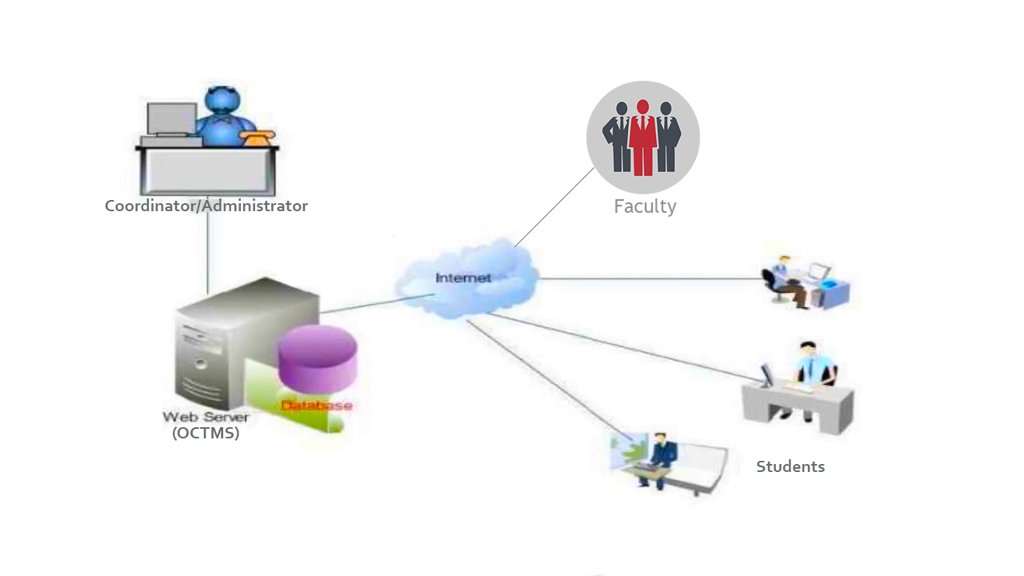

Fig 2.2: Example of OCTMS

[1] Find the demo on You Tube: https://youtu.be/UC1FXDKVdUcbe

Chapter III

1. Development Methodology
   1. Tools

|  |  |
| --- | --- |
| PHP | : Programming Language |
| MySQL | : Database |
| Laravel | : Framework |
| JavaScript | : Scripting Language |
| HTML, CSS, Bootstrap | : Front end design |

* 1. Conceptual Mind map

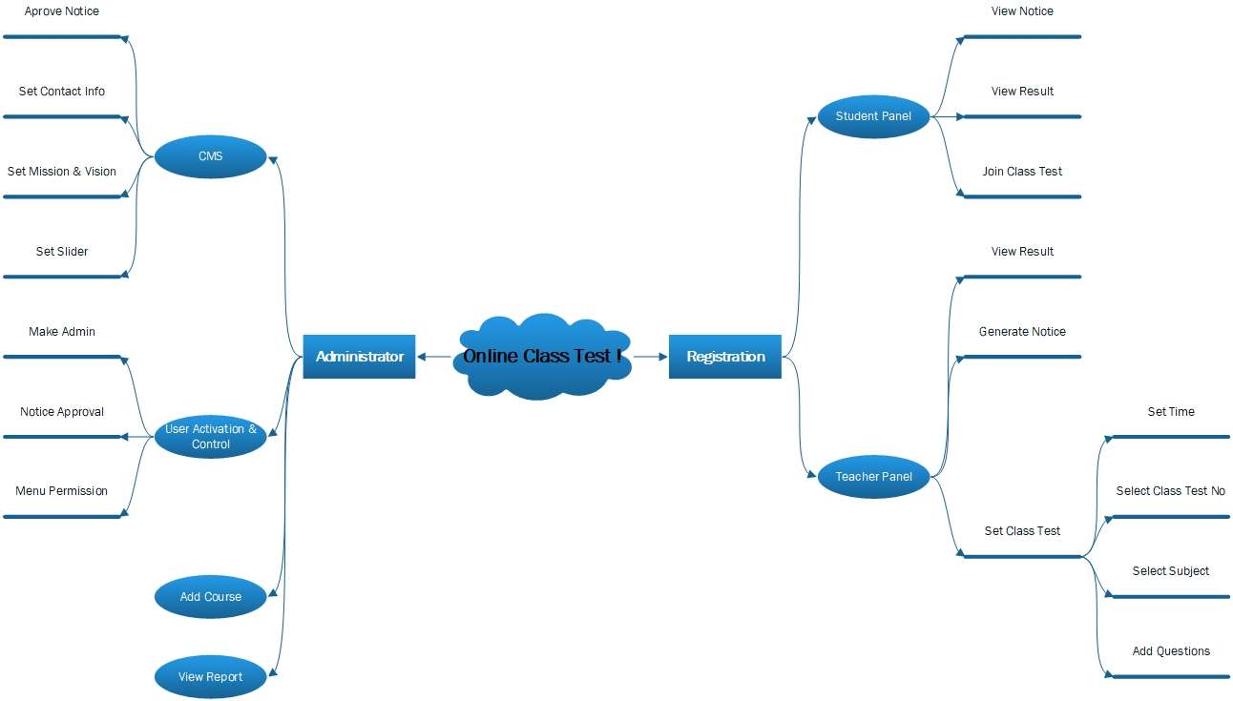

Fig 3.1: Conceptual Mind Map

* 1. System Architecture

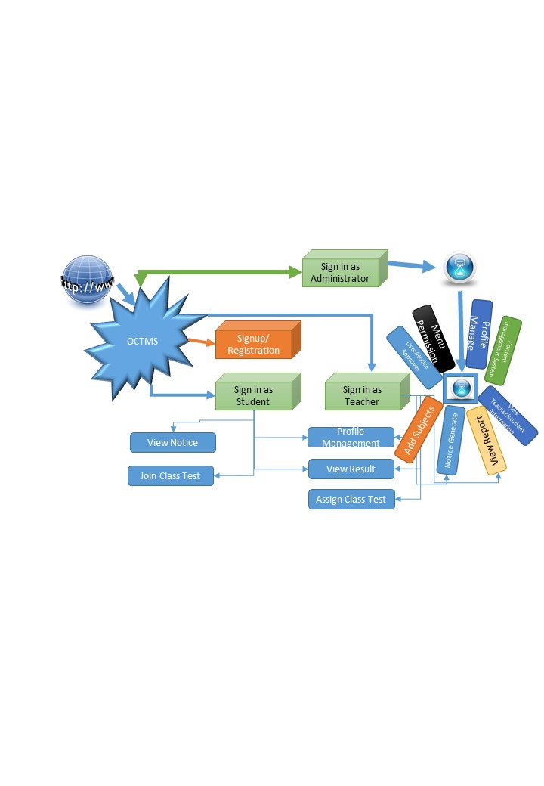

Fig 3.2: System Architecture

* 1. Case Diagram

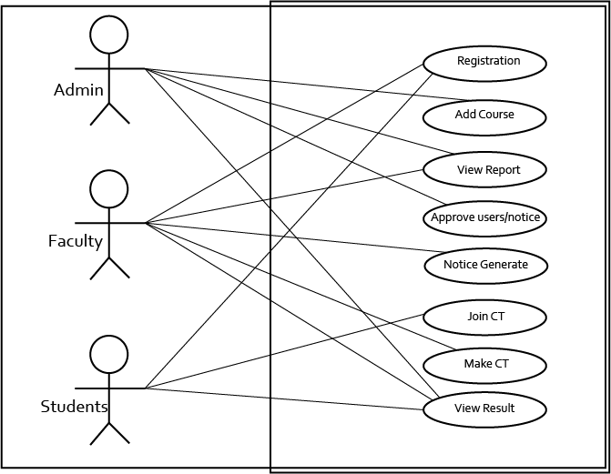

Fig 3.3: Case Diagram

* 1. Database Design

Fig 3.6: Database Design

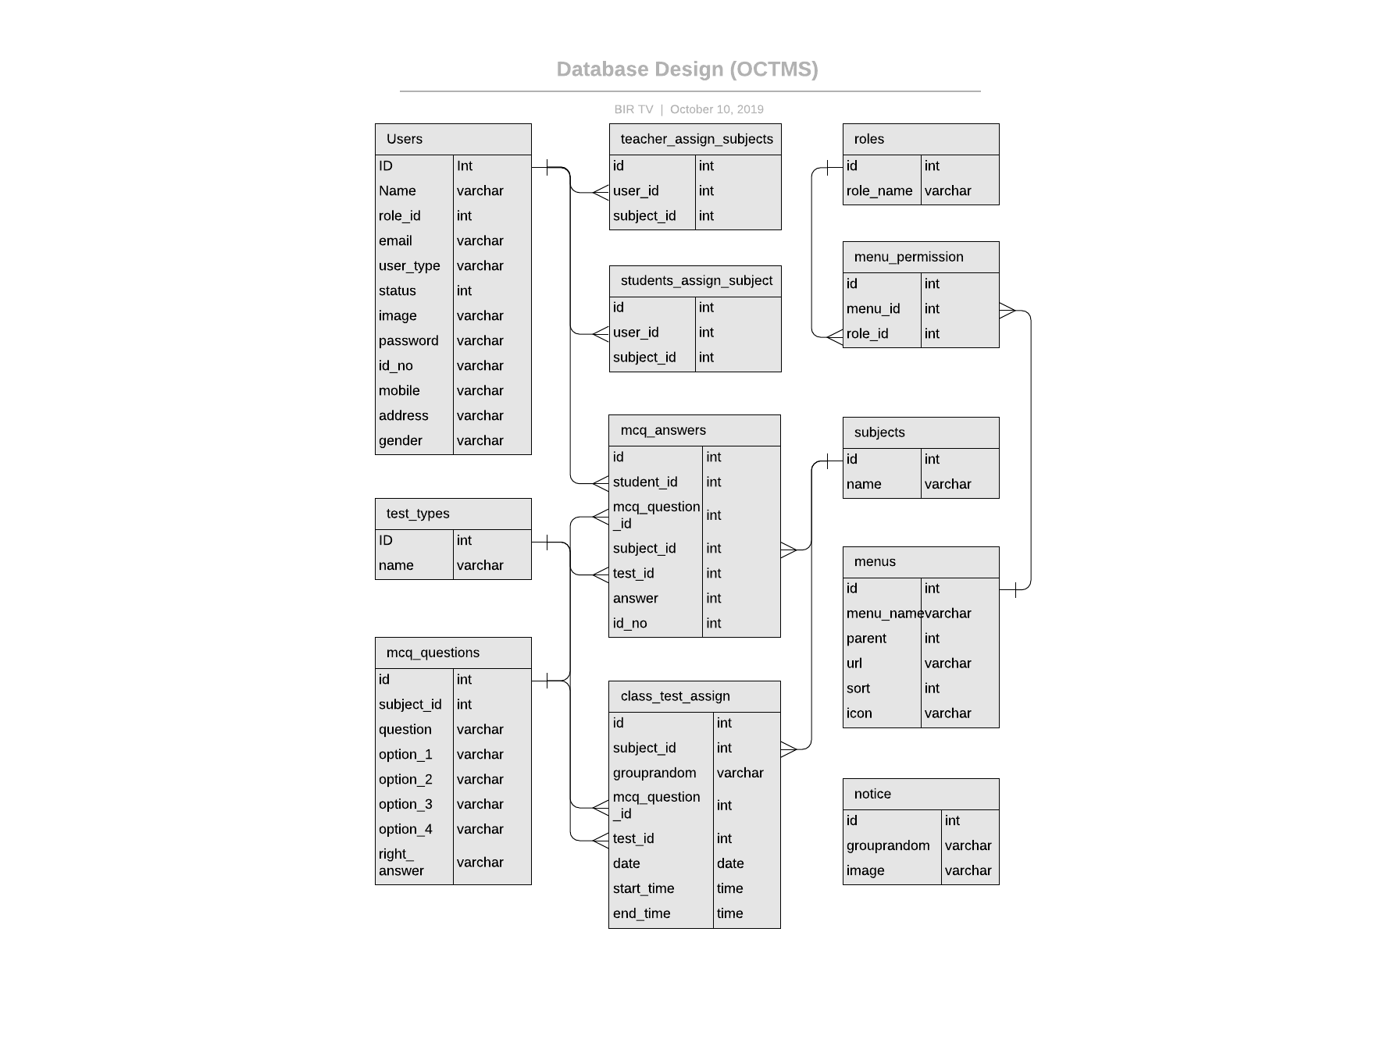

Chapter IV

1. Project Demo
   1. Home

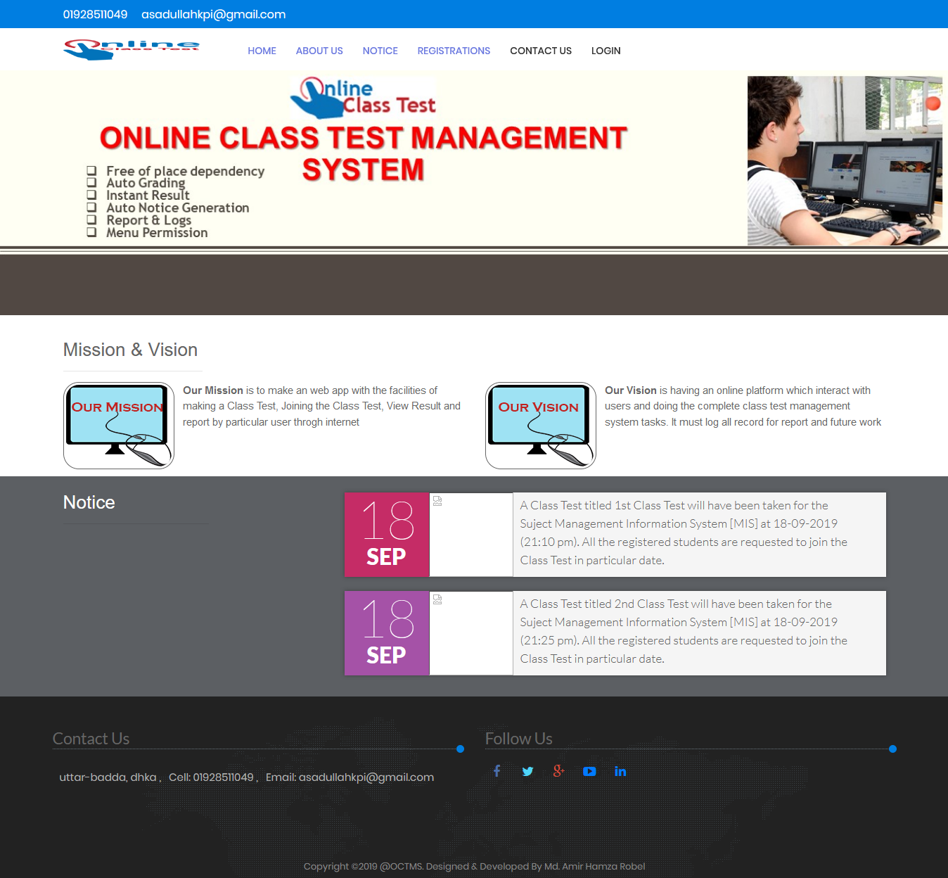

Fig 4.1: Home Page

We are trying to make an attractive and responsive homepage .A responsive design is an approach where the web designer wants to reach an optimal web experience for a wide range of devices. A responsive site scales with the size of the screen without sacrificing the text readability or usability of the user interface.

* 1. Admin Dashboard

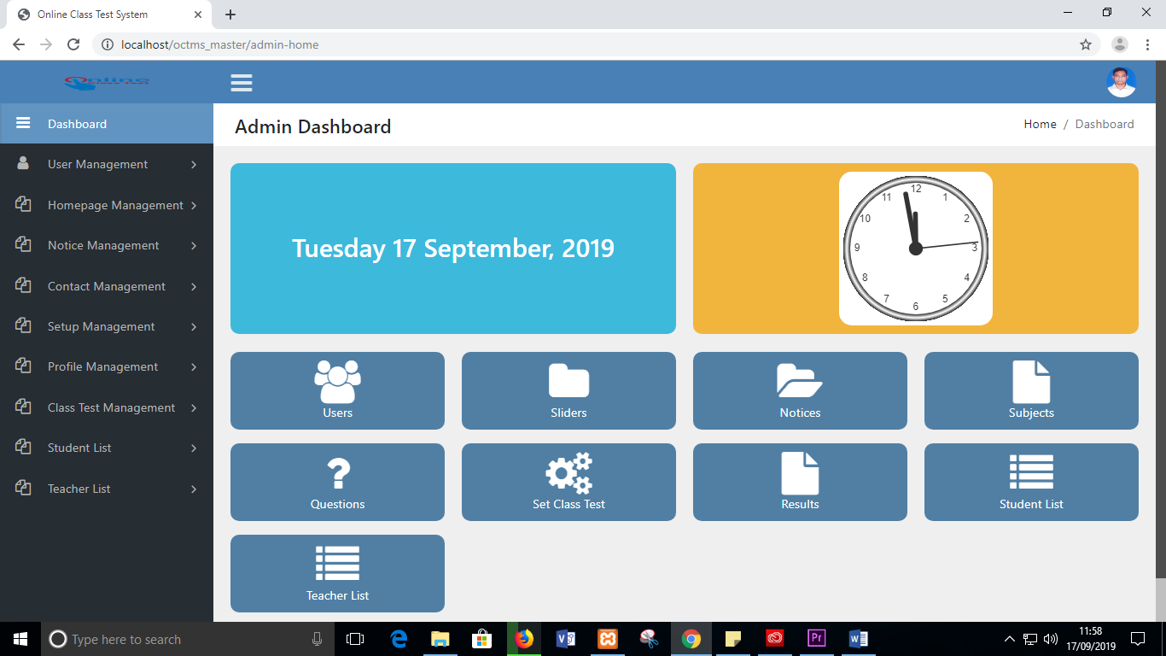

Fig 4.2: Admin Dashboard

Admin has the supreme authentication and control over all of the functions. we can see the functions of an admin in figure above. There have seven categories of functions with multiple submenus. Another figure has been added below to illustrate menu permission.

Fig 4.2.1: Illustration of menu permission [color wise]

Administrator

All Users

Teacher

Student

* 1. Teacher Dashboard

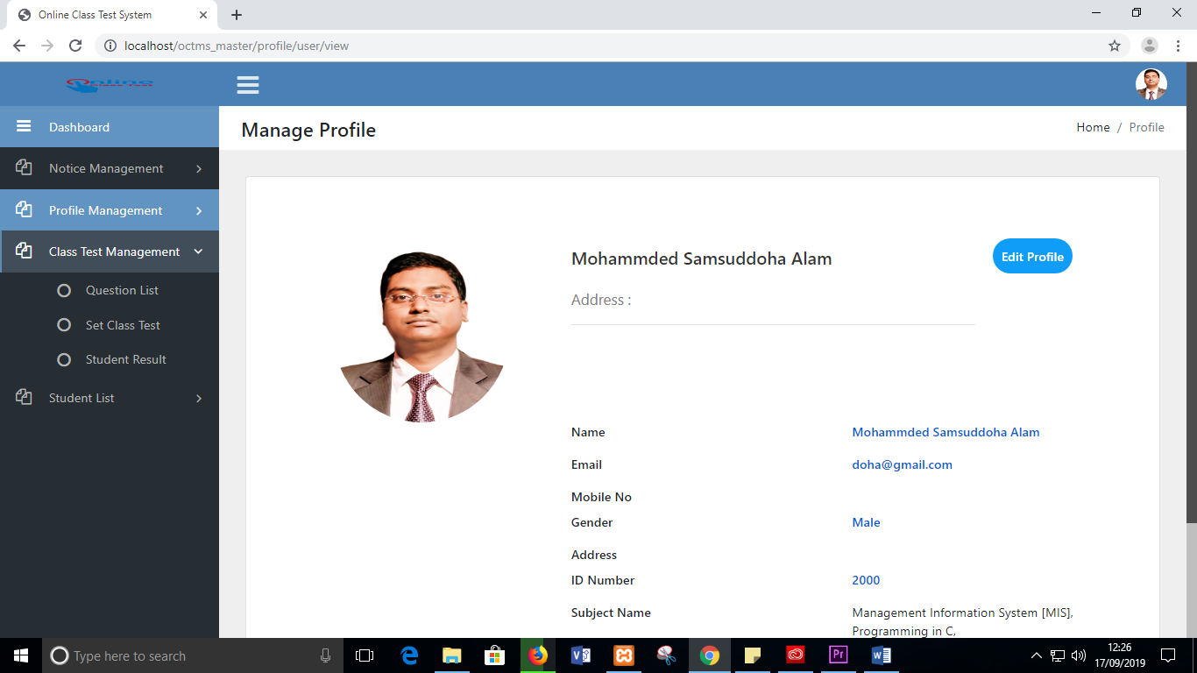

Fig 4.3: Teacher Dashboard

* 1. Student Dashboard

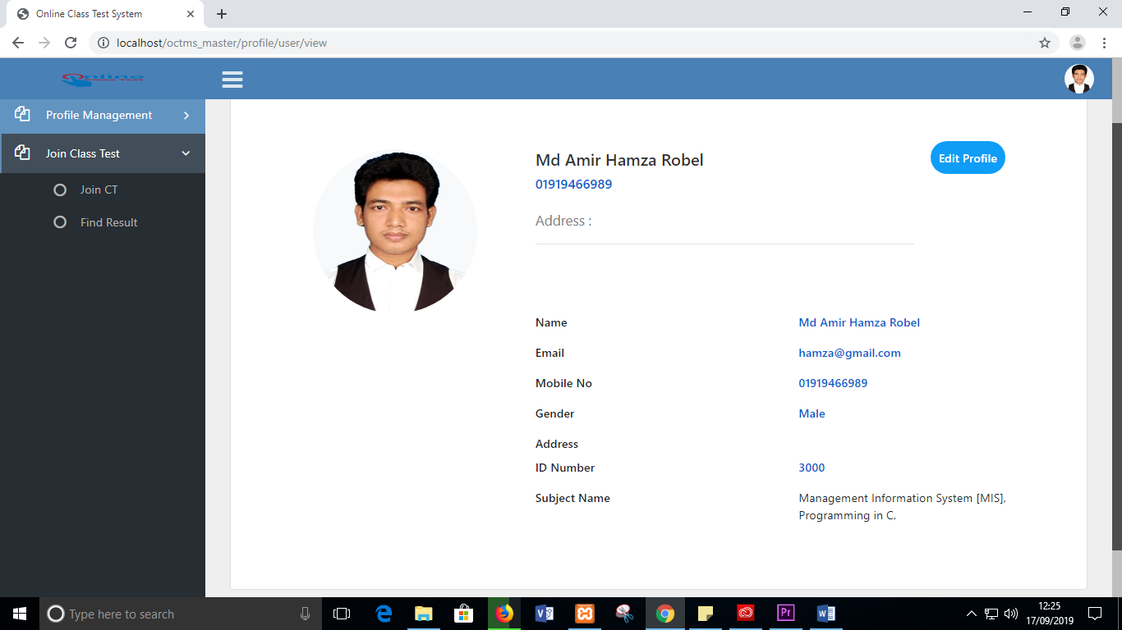

Fig 4.4: Student Dashboard

* 1. Make CT

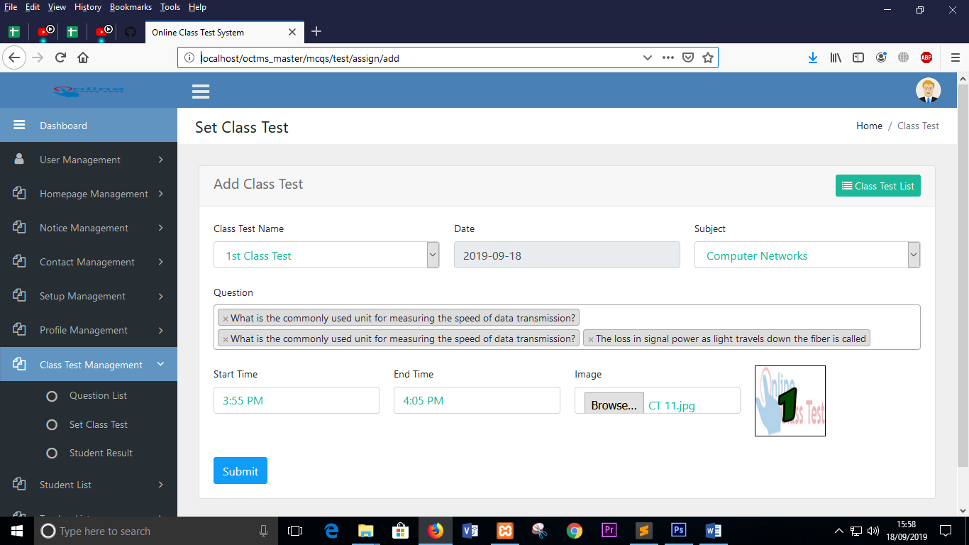

Fig 4.5: Class Test Assigning

We can see in the figure above that teacher can announce a CT by clicking the submenu ‘Set Class Test’ under the “Class Test Management” menu. Now the teacher has to choose all of those attribute values respectively and finish by clicking submit button

* 1. Join CT

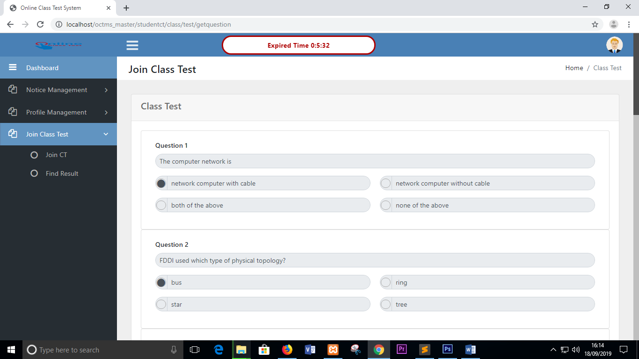

Fig 4.6: Joining Class Test

* 1. Result

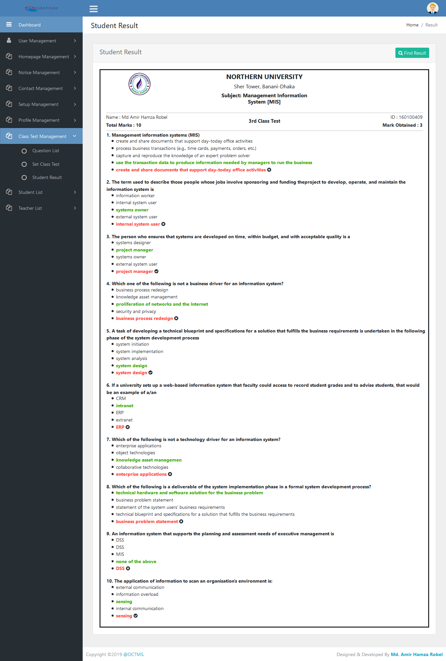

Fig 4.7: Result

* 1. Performance Report

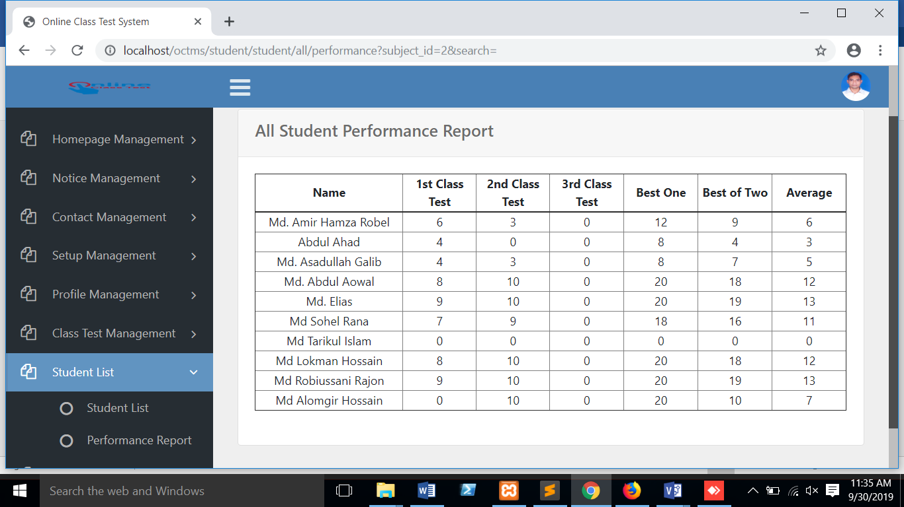

Fig 4.8: Performance Report

Chapter V

1. Conclusion
   1. Project Limitations

* We have been able to generate notice automatically then send it on the homepage and User dashboard but we haven’t able to make it as notification
* This project hasn’t included the text/figure/fill in the blank related Q&A, only MCQs
* We have developed subject wise registration but it could have been more efficient if we included semester wise registration
  1. Future Scopes

At present we can only able to take MCQ exam through this system but in future we can reformulate the question system and answering pad which must give us a platform where we can arrange theoretical test like midterm exam and even viva will have been taken via this system. We can consider this system as a module of the official site of an institute instead of individual site. Of course, cheat detector procedure should be added which can automatically and continuously detects cheat behaviors during online exams based on the audio–visual streams captured by a webcam, a webcam with an integrated microphone.

Glossary

**OCTMS:** - Online Class Test Management System.

**Dashboard:** - User individual panel basically a graphical user interface

**DBMS :** - Database Management System

**PHP:** - PHP (recursive acronym for PHP: Hypertext Preprocessor) is a widely-used open source general-purpose scripting language that is especially suited for web development and can be embedded into HTML.

**CMS:** - Content Management System (CMS)allows you to update your website's content yourself. For example, if you want to edit the wording of a page on your website, delete a blog entry or add a picture, you would simply login to your Website Dashboard and easily make this change yourself.

**FULL STACK: -** A full stack web developer is a person who can develop both **client** and **server** software. In addition to mastering HTML and CSS, he/she also knows how to: 1. Program a **browser** (we are using JavaScript, jQuery), 2. Program a **server** (we are using PHP) and 3. Program a **database** (like using SQL, SQLite, or MongoDB).

**RESPONSIVE WEB DESIGN: -** Responsive Web Design is about using HTML and CSS to automatically resize, hide, shrink, or enlarge, a website, to make it look good on all devices (desktops, tablets, and phones).

**FONT AWESOME:** Font Awesome is a [font](https://en.wikipedia.org/wiki/Font) and [icon](https://en.wikipedia.org/wiki/Icon_(computing)) toolkit based on [CSS](https://en.wikipedia.org/wiki/CSS) and [LESS](https://en.wikipedia.org/wiki/Less_(stylesheet_language)). It was made by Dave Gandy for use with [Twitter Bootstrap](https://en.wikipedia.org/wiki/Twitter_Bootstrap), and later was incorporated into the [BootstrapCDN](https://en.wikipedia.org/wiki/BootstrapCDN). Font Awesome has a 20% market share among those websites which use third-party Font Scripts on their platform, ranking it second place after [Google Fonts](https://en.wikipedia.org/wiki/Google_Fonts).

References

1. [Matt Stauffer](http://www.oreilly.com/pub/au/6605), “Laravel: Up and Running, 2nd Edition*,* A framework for building modern apps*”* O’Railly Media, pp. 544, Apr. 2019.
2. Luke Welling and Laora Thomson, “*PHP and MySQL web development, 5th Edition*”

Addison-Wesley Professional, pp. 488-537, Sep. 2016

1. Yousef Atoum, Liping Chen, Alex X.Liu, Stephen D.H.Hsu and Xiaming Liu “Automated Online Exam Proctoring,” published in IEEE Transactions on Multimedia*,* vol. 19, Issue.7, pp. 1609-1624, July 2017
2. T. L. Gilbert, *Formulation, Foundations and Applications of the Phenomenological Theory of Ferromagnetism,* Ph.D. dissertation, Illinois Inst. Tech., Chicago, IL, 1956, unpublished
3. Rasha Ismail, Fadi Safieddine, Ashraf Jaradat, "E-university delivery model: handling the evaluation process", *Business Process Management Journal*, 2019.
4. Mohammad A Sarrayrih and Mohammed Ilyas, “Challenges of Online Exam, Performances and problems for Online University Exam,” IJCSI International Journal of Computer Science Issues, Vol. 10, Issue 1, No 1, January 2013 ISSN (Print): 1694-0784 | ISSN (Online): 1694-0814
5. Shan Wei-feng, Huang Meng, Li Jun, “An Online Examination System supporting User Define Question Type,” International Conference on Education Technology Computer, 2010

[8] [https://www.w3schools.com](https://www.w3schools.com/php/default.asp)

[9] <https://fontawesome.com>

[10] Terry McNavage, JavaScript for Absolute Beginners, 2010, ISBN-13 (pbk):

978-1-4302-7219-9

1. The link mentioned on 2.2 is a reference of an online video which contains the quick review/demo of our project.